**Taxonomy for open planet portal (Version 2.0)**

* SDG Goals and Targets

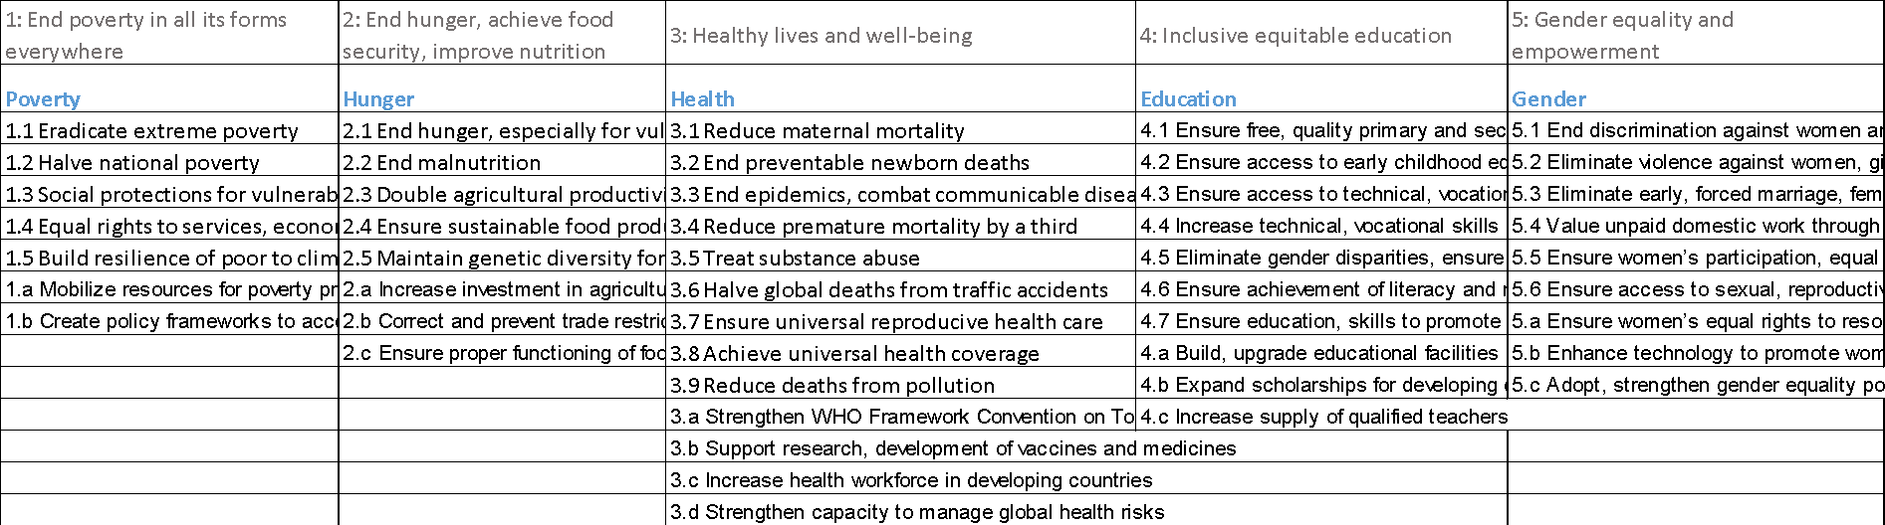

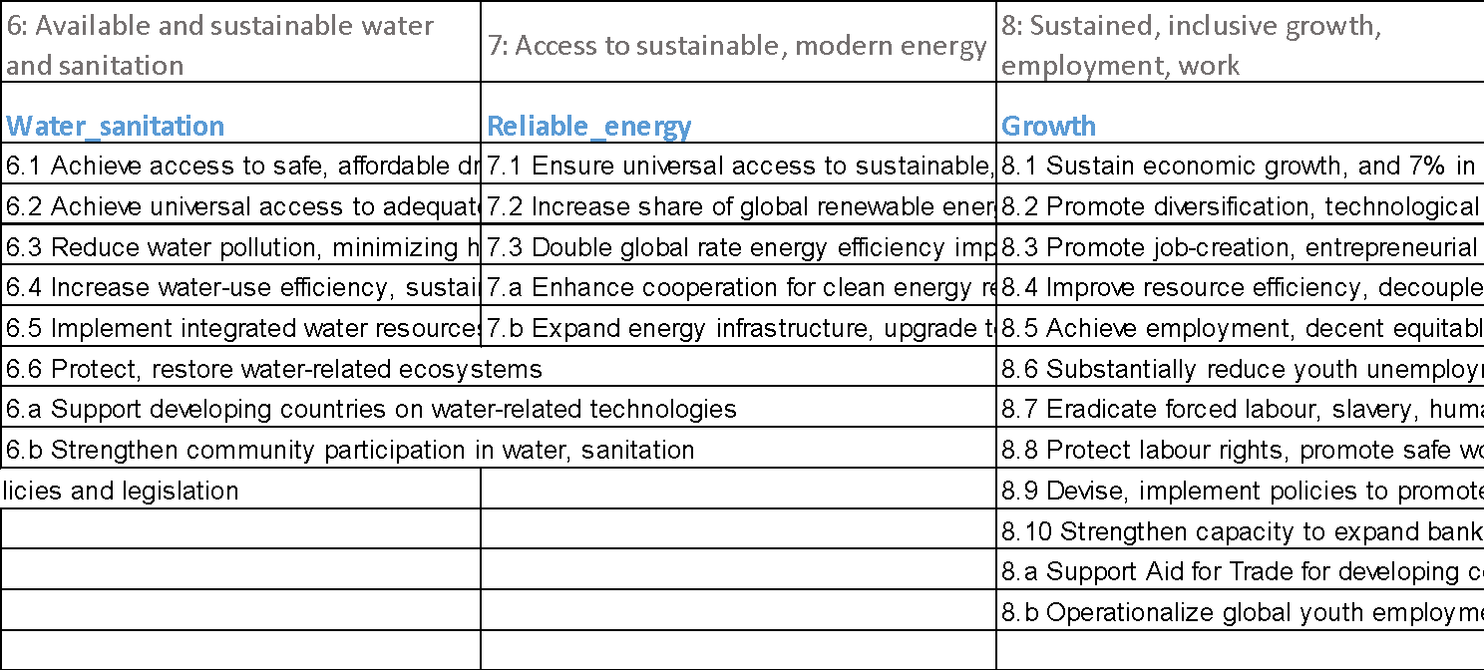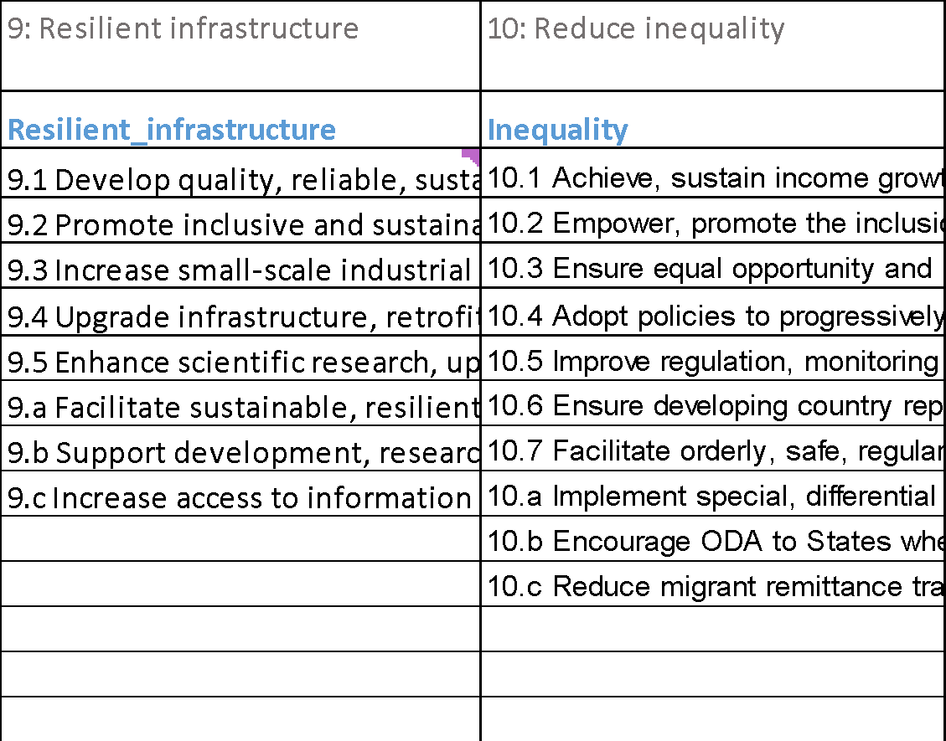

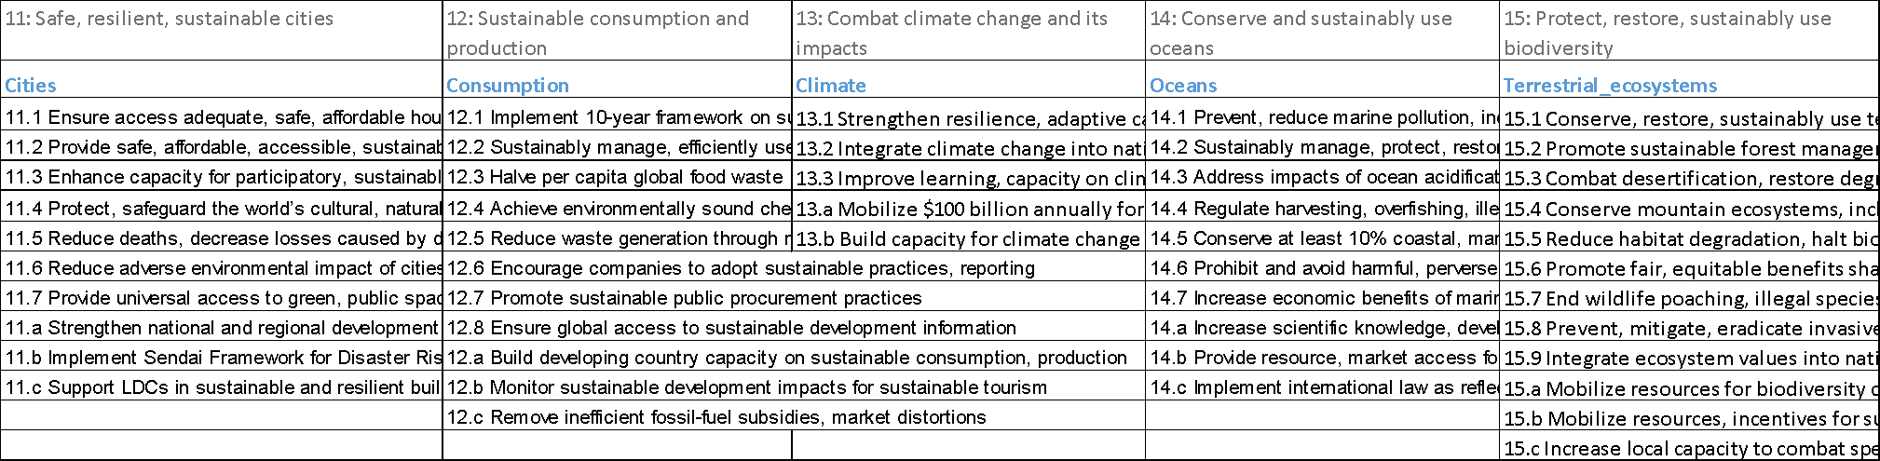

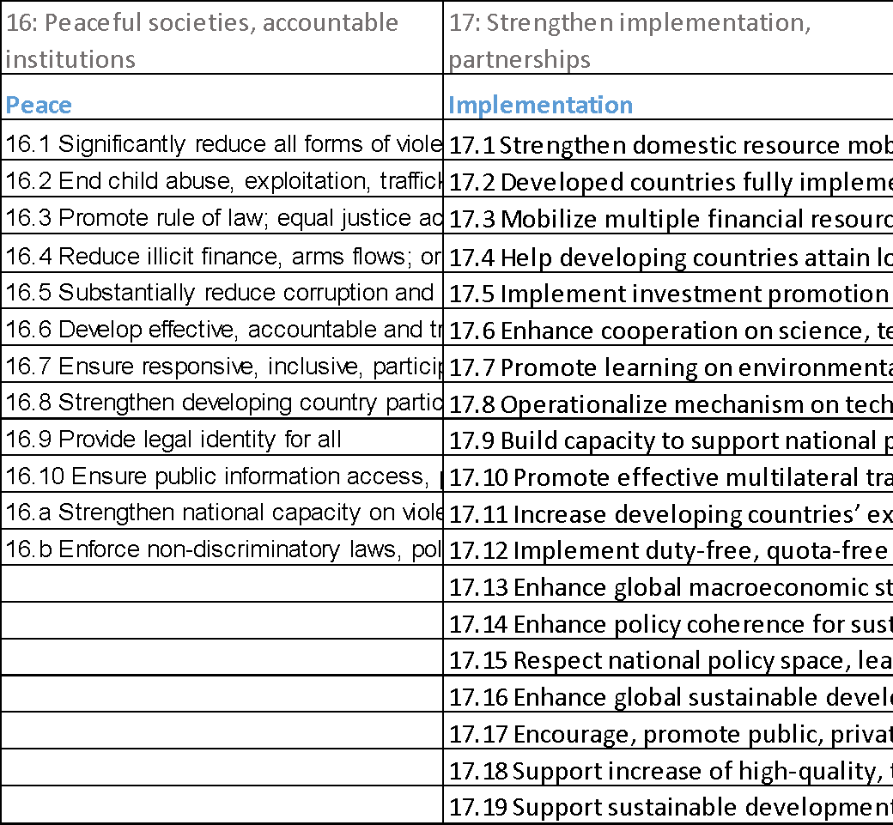

* Thematic areas

1. Technical teams

|  |  |
| --- | --- |
| **Ecosystems_and_Biodiversity_Programme** | **Climate_Change_Mitigation_Programme** |
| Mainstreaming Biodiversity | ***Energy Program*** |
| Strengthening conservation areas | **Energy_Efficiency** |
| Ecosystem management and restoration | ---Appliances |
| *\*\*\*Remember to tag the sectors that are transformed. Sub-tags as below apply to all the three themes* | ---Agriculture/irrigation |
| ---Access and benefit sharing | ---Buildings |
| ---Agrobiodiversity | ---Cooling |
| **Chemicals_and_Waste_Programme** | ---Emobility |
| Persistent Organic Pollutants | ---Industrial |
| ---Pesticide | ---Lighting |
| ---Flame retardants | ---Transport |
| ---Unintentional POPs (e.g. furans, dioxins) | **Renewable_Energy** |
| Ozone Depleting Substances | ***Tag both type and resource |
| ---CFCs | Type: On-grid, utility-scale |
| ---HCFCs | Type: On-grid, rooftop |
| Heavy metals | Type: Off-grid, mini-grids |
| ---Mercury | Type: Off-grid, standalone systems |
| ---Lead | Type: Thermal |
| ---Source from ASGM | Resource: Battery |
| ---Source from Health sector | Resource: Biomass |
| ---Source from Industrial processes | Resource: Diesel hybrid |
| Waste Management | Resource: Geothermal |
| ---Hazardous chemical waste (e.g. legacy waste) | Resource: Hydro |
| ---Waste to energy | Resource: Solar |
| ---E-waste | Resource: Waste (municipal) |
| HFCs | Resource: Waste (agriculture) |
| Cooling Alternatives | Resource: Wind |
| ***Remember to choose cooling "strategy" under Technology_Innovation | **Energy_Access** |
| ---Natural Refrigerants (CO2, Ammonia, Propane, Isobutane) | ---Clean cooking |
| ---HFOs | ---Sustainable charcoal |
| ---Not-in-kind technology (alternative cooling systems, e.g. heat pumps, district cooling) | **Miscellaneous_Energy_Program** |
|  | ---Carbon Pricing |
| **Oceans_and_Water_Programme** | ---Crisis |
| Climate Resilient Access to Water Supply & Sanitation​ | ---Digital |
| Protection of Transboundary Surface & Groundwater Resources in a Changing Climate ​ | ---Enabling activities |
| Climate Resilient Integrated Water Resource & Coastal Area Management​ | ---Fossil fuel subsidy reform |
| Sustainable Management of Oceans in a Changing Climate​ | ---Health |
| Cross Cutting Governance and Learning​ | ---Sustainable cities |
| *Small Island Dev States Program (SIDS)* | ---Tourism |
|  | ---Other energy projects |
| **Climate_Change_Adaptation_Programme** | ***Climate and Forest Program*** |
| Mainstreaming integrated policy and planning for climate-resilient & sustainable development | ---Carbon conservation |
| Cross-sectoral climate resilient livelihoods | ---Carbon sequestration |
| Fostering Food Security and resilient Agricultural systems | *---Climate Financing for REDD/REDD+* |
| Ecosystem-based adaptation |  |
| Climate Resilient Integrated Water Resource and Coastal Management |  |
| Urban Resilience |  |
| Climate Information and Early Warning Systems (CI & EWS) | **Climate_Strategies_and_Policy_Programme** |
|  | ***Link to all the existing tags under each technical team |
| **Environmental_Governance_Programme** | ***Its own categories as below are listed in a separate column |
| Mainstreaming Green Economy | Capacity Development |
| Global Flagship Programmes | CBIT (Capacity-building initiative for transparency) |
| ---PAGE​ (Partnership for Action on Green Economy) | GCF Readiness |
| ---PEA (Poverty-Environment Action) | National Communications |
| ---GCP (Green Commodities Programme) | Small Grants Programme (global level) |
| New Programmes and Pilots | Small Grants Programme (country level) |
| ---One Planet network ​ |  |

1. Landscapes

|  |  |
| --- | --- |
| **Forest** | **Conserved_Areas** |
| ---Boreal forests (Taiga forests) | ---Marine and Coastal Protected Areas |
| ---Tropical forests | ---Terrestrial Protected Areas |
| ---Temperate forests | ---Indigenous and Communities Conserved Area (ICCA) |
| ---Dryland forests | ---Specially Protected Areas (SPAs) |
| ---Montane forests | ---Transboundary Conservation Area |
| ---Intact forests | ---Productive Landscapes/Seascapes |
|  | ---Key Biodiversity Area (KBA) |
| **Tundra** | ------Important Bird and Biodiversity Areas (IBAs) |
| ---Arctic tundra | ---OECM (conserved areas other than protected areas) |
| ---Alpine tundra |  |
| ---Antarctic tundra | **Marine** |
|  | ---Seas |
| **FreshWater** | ---Coasts |
| ---Rivers and river basins | ---Seagrasses |
| ---Lakes | ---Coral reefs |
| ---Aquifers | ---Ice/ Glacier |
| ---Estuaries | ---Large marine ecosystem |
|  | ---Exclusive economic zone |
| **Grassland** | ---Areas beyond National Jurisdiction |
| ---Grazing Land | ---Rift valley |
| ---Tropical Grassland | **Wetlands** |
| ---Temperate grassland (Prairie) | ---Mangroves |
| ---Savanna | ---Marshes |
| ---Steppes | ---Peatlands |
| ---Drylands | ---Swamps |
|  |  |
| **Desert** | **Human-altered areas** |
| ---Sub-tropical (hot and dry) desert | ---Urban area |
| ---Semi-arid (cold winter) desert | ---Rural area |
| ---Coast desert | ---Mining site |
| ---Cold (polar) desert | ---Industrial site |
|  | ---Heritage site |
|  | ---Contaminated site |

1. Sectors to be transformed

|  |
| --- |
| Agriculture |
| Aquaculture |
| Fisheries |
| Forestry and other land use |
| Livestock |
| Materials and Manufacturing |
| ---Metals and Mining |
| ------ASGM |
| Energy |
| ---Oil, gas and fuels |
| ---Coal |
| Transportation |
| ---Shipping |
| Retail |
| Tourism |
| Electronic |
| Health Care |
| Other sectors |

* Strategies

|  |  |
| --- | --- |
| **Governance** | **Law_Regulation** |
| Institutional framework | Laws/ Policy formulation |
| Partnerships | Standards/ Labeling/ Guideline |
| Transboundary governance | Laws enforcement/ Regulation |
| Inter-sectoral coordination | Conflict resolution |
| Adaptive governance | Pollution control |
| Alternative governance models | Surveillance & Compliance |
| ---Co-management |  |
| ---Community Governance | **Monitor_Inventory** |
| ---Cooperative | Data quality |
| Transparency governance | Impact assessment |
|  | Waste/pollutants monitoring |
| **Finance_Economy** | Water quality/quantity |
| Nature finance | Ecological monitoring |
| ---Conservation trust funds | ---Species survey |
| ---Payment for ecosystem services | ---Forest survey |
| ---Biodiversity finance | ---Coral reef survey |
| Energy finance | Spatial monitoring/analysis |
| Circular economy | Ecosystem services monitoring |
| Blue economy | Management effectiveness (METT) |
| Green economy | Accounting |
| ---Carbon pricing | ---Natural capital assessment and accounting |
| ---Fossil fuel subsidy reform | ---GHG accounting |
| ---Green marketing | Knowledge/Data management |
| Financial screening |  |
| New/other financial schemes/mechanism |  |
| Fiscal planning |  |
| **Enabling** | **Education_Capacity** |
| Mainstream | Awareness raising |
| Alignment | Research |
| Advocacy (towards decision makers) | Institutional capacity building |
| Public campaign | Community capacity building |
| Community engagement | Technical capacity building |
|  | Education/Courses |
| **Food_and_Agricultural_Commodities** | Traditional knowledge application |
| Improved & diversified sustainable livelihoods (TP5) | Portfolio learning |
| ---Beekeeping |  |
| ---Agroforestry | **Mitigation_Adaptation** |
| ---Apiculture | Species adaptation |
| Sustainable agriculture practices and use of resources (TP 2,7, 8, 9) | Ecosystem mitigation and adaptation |
| ---Water for food (TP 8) | Drought Mitigation/Early Warning |
| ---Clean energy for food (TP 2) | Flood prevention/Early Warning |
| ---Land for food (TP7) | Sustainable Fire Management |
| Climate resilience for FAC system (TP 6) | Erosion prevention |
| Food strategies for sustainable supply chain (TP 4) | Heatwave adaptation/Early Warning |
| ---Policies, investment and incentives for food sustainability (New TP4) | Storm mitigation |
| ---Transparent supply chains and improved governance on FACS (New TP5) | Coastal risk reduction |
| ---Market and consumer demand for healthy and sustainable products (New TP6) | Sea level rise |
| Crops diversity, nutrition and ABS (TP 1, 10) | Infrastructure against natural hazards |
| Food loss and waste reduction (TP3) | Ocean acidification |
|  | Blue carbon |
|  |  |
| **Technology_Innovation** | **Management_Operation** |
| Transition to safer alternatives | Ecosystem-based management |
| Cooling Energy Efficiency | Sustainable land management |
| ---Replacement/Updating of compressors | ---Sustainable agriculture/rangeland/pasture |
| ---Replacement/Updating of heat exchangers | ---Sustainable forest management |
| Alternative Energy Sources | -----High carbon stock forest |
| ---Hydro | ---Land degradation/desertification |
| ---Biomass | Ecosystem services conservation/restoration |
| ---Wind | Conserved areas/ protected areas management |
| ---Solar | ---Conserved areas/ protected areas expansion |
| Urban green space | Wildlife and habitat conservation |
| Green building practices | ---Wildlife corridors and habitat connectivity |
| Biochar (soil amendment) | ---Illegal wildlife trade/trafficking |
| Clearing house mechanism | Genetic diversity |
| Improved Soil and Water Management Techniques | Invasive and alien species (IAS) |
| Water supply and sanitation | Management effectiveness (METT) |
| Infrastructure building | Integrated water resource management |
| Rainwater harvesting | Integrated River Basin Management |
| Best Available Techniques & Best Environmental Practices (BAT & BEP) | Marine Spatial Planning, |
| Innovations in Techniques/ Approaches | Locally Managed Marine Area |
|  | Integrated coastal zone management |
|  | Waste management |
|  | Wastewater management |
|  | Demonstration sites/Pilot |

* Cross-cutting areas

|  |  |
| --- | --- |
| **Pathways** | **Risk Reduction Target** |
| People pathway | Hazard Control/Mitigation |
| Systems pathway | Reduce Exposure |
| Sci-tech pathway | Improve Resilience |
|  |  |
| **Social Inclusion and Engagement** | **PROTOCOLS_PLANS** |
| Youth/Children | NDC |
| Disabled | Strategic Action Programme |
| Elderly | NBSAP |
| Women | National Action Plan |
| Refugees/Displaced | National Communications |
| Indigenous | National Development Policies |
| Local Community/CSOs | Nagoya protocol (ABS) |
| Private Sector | Cartagena Protocol on Biosafety (LMOs, GMOs) |
| Artisanal miners | Montreal Protocols |
| Waste picker | Stockholm Convention (POPs) |
|  | UNFCCC |
| **Gender Result Effectiveness Scale** | Minamata Convention on Mercury |
| Gender blind | Regional Seas Conventions and Action Plans |
| Gender responsive | LME Conventions |
| Gender targeted | International Maritime Organization Conventions (IME) |
| Gender transformational | Other global conventions |
|  |  |
| **Gender Equality** | **Private Sector Type** |
| Women's access to and control over resources | Capital providers |
| Women decision making | Financial intermediaries and market facilitators |
| Land rights for women | Large corporations |
| Women Farmers | Small and Medium-sized Enterprises |
| Livelihoods for women | Individuals/Entrepreneurs |
| Women's cooperatives and groups | Non-Grant Pilot |
| Awareness raising (on gender) | Project Reflow |
| Women park rangers |  |
| Gender-responsive policies |  |

|  |
| --- |
| **HOT_TOPICS** |
| Health |
| Human rights |
| Cov-19 |
| Green Recovery |
| Structural/system transformation |
| Digital transformation |
| Poverty reduction |
| Multi-stakeholder collaboration |
| Public-private partnership |
| Nature-based solution |
| SIDS |
| Crisis setting |
| Leaving no one behind |
| Plastic |

1. Link to SGP website? - API? - Frequency of the updates (Annual updates) (portfolio profile - regional allocation of grant amount/co-financing/funder/themes?) - cautions on sharing with public - Figures (annual updates)
2. Grant amount for each child project?
3. Taxonomy mapping - accumulated (by end next week)
4. Community-based taxonomy
5. Possibility of piloting countries, machine learning